Notice for Practical examination
It is hereby informed to all the students of 1st, 3rd and 5th semester Major and Minor course that the FYUGP B.Sc. Physics practical examination, 2025-26 will be held as per the following schedule.
Course name |  | Date and Time
 |  | Practical examination time | Viva
1st semester Major | PHY0100104MJ (Mathematical Physics & Mechanics) | 22.12.2025, 9.00 am | 23.12.2025, 11.00 am
1st semester Minor | PHY0100104MN (Mathematical Physics & Mechanics) | 23.12.2025, 9.00 am | 23.12.2025, 12.00 pm
3rd semester Major | PHY0300104MJ  (Wave & Optics) | 19.12.2025, 9.00 am | 19.12.2025, 12.30 pm
3rd semester Major | PHY0300204MJ  (Electromagnetic Theory) | 27.12.2025 | 27.12.2025
3rd semester Minor | PHY0300104MN  (Wave & Optics) | 19.12.2025, 10.00 am | 19.12.2025, 1 pm
5th Semester Major | PHY0500304  (Heat & Thermodynamics) | 26.12.2025, 9 am | 27.12.2025
5th Semester Major | PHY0500204  (Condensed Matter Physics) | 26.12.2025, 12 pm | 27.12.2025
5th Semester Major | PHY0500404  (Electromagnetic Theory) | 27.12.2025 | 27.12.2025

All the students are requested to submit their practical copies before the start of the practical exam.
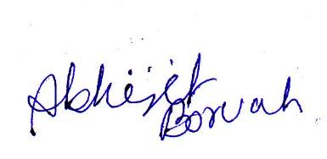
Dr. Abhijit Boruah
Head, Department of Physics
Barkhetri College

